

Hardware Requirements & Design Document
For The
ACMEY Company Avionics Passenger Counter
Document No: 800-HRD-01
Revision:0.1

__________________________________________________ |  |  | ___________
Project Manager |  | Date
__________________________________________________ |  | ___________
Technical Project Lead |  | Date
__________________________________________________ |  | ___________
Principal Design Engineer |  | Date
__________________________________________________ |  | ___________
Principal Quality Engineer |  | Date

Notice
This document and the information contained herein are the property of Airworthiness Certification Services LLC. Any reproduction, disclosure or use thereof is prohibited except as authorized in writing by Airworthiness Certification Services LLC. Recipient accepts the responsibility for maintaining the confidentiality of the contents of this document.

REVISIONS
Rev | Reason/Description | Requested/  Changed By | Date
0.1 | Initial Draft | N/A

Table of Contents

Section Page
1.0 INTRODUCTION 4
1.1 Purpose 4
1.2 Scope 4
1.3 Acronyms and Abbreviations 5
1.4.1 External Documents 6
1.4.2 Internal Documents 6
2.0 SYSTEM OVERVIEW 7
2.1 System Functional Description 7
2.2 System Architecture 7
2.3 System Requirements 8
3.0 HARDWARE OVERVIEW 10
3.1 Hardware Functions 10
3.2 Hardware Architecture 10
3.2.1 Computation 11
3.2.2 Entry/Exit sensor 12
3.2.3 Keypad Entry Panel 12
3.2.4 Display Panel 12
3.2.5 PIC Controller Interface & Fault Monitoring 13
3.2.5.1 PIC Controller & ARINC 429 FPGA Interface 14
3.3 Hardware Safety and Partitioning 15
4.0 HARDWARE REQUIREMENTS IDENTIFICATION 16
4.1 System Level Requirements Allocated to Hardware 16
4.2 High-Level Hardware Requirements Definition 16
4.3 Regulatory Compliance 16
4.4 Computation 16
4.5 Entry / Exit Detection 17
4.6 Keypad Entry 17
4.7 Display 17
4.8 Fault Monitoring and ARINC 429 Data Transmit 18
5.0 Passenger Counter FPGA Requirements Diagram 21
6.0 REQUIREMENTS TRACEABILITY MATRIX 22

1.0 INTRODUCTION

1.1 Purpose

This Hardware Requirements Document (HRD) identifies the functional, performance, safety, quality, maintainability, and reliability requirements for the hardware item being developed for the Avionics Passenger Counter. This HRD establishes the basis for Hardware development and requirements-based testing.

1.2 Scope

This HRD contains, but is not limited to, the operational and performance requirements for each function; the memory and timing requirements, the hardware / Hardware interface requirements, and the monitoring requirements. This HRD complies with the documentation requirements of RTCA/DO-254 for the Hardware and FPGA requirements.

1.3 Acronyms and Abbreviations

AIMS Action Item Management System
ALU Arithmetic Logic Unit
ARP Aerospace Recommended Practice
ASIC Application Specific Integrated Circuit
DRMS Document Review Management System
HC1 Hardware Control Category 1
HC2 Hardware Control Category 2
COTS Commercial-Off-The-Shelf
EUROCAE European Organization for Civil Aviation Equipment
FAR Federal Aviation Regulations
FFP Functional Failure Path
FFPA Functional Failure Path Analysis
FHA Functional Hazard Assessment
F-FMEA Functional Failure Modes and Effects Analysis
FTA Fault Tree Analysis
HDL Hardware Description Language
JAR Joint Aviation Requirements
LRU Line Replaceable Unit
PHAC Plan for Hardware Aspects of Certification
PLD Programmable Logic Device
PSSA Preliminary System Safety Assessment
RTMS Requirements Traceability Management System
SAE Society of Automotive Engineers
SC Special Committee
SSA System Safety Assessment
WG Working Group

1.4 Applicable Documents

The following documents are listed for reference only. Each document is applicable to this plan only to the extent specified herein.

1.4.1 External Documents

RTCA/DO-254 Design Assurance for Airborne Electronic Hardware

FAA Order 8110.105 Simple and Complex Electronic Hardware Approval Guidelines

FAA Order 8110.4C Type Certification

AC 20-152 Advisory Circular, RTCA Inc., Document DO-254, Design Assurance
for Airborne Electronic Hardware

1.4.2 Internal Documents

800-HRD-01 Hardware Requirements Document

800-HRS-01 Hardware Requirements Standards

2.0 SYSTEM OVERVIEW

2.1 System Functional Description

The Avionics Passenger Counter is a module that will keep track of how many passengers are currently in the aircraft/cabin. The current number of passengers in the cabin will be displayed on a display panel in real-time. The system will have a keypad entry so that the flight attendant can enter a passenger headcount correction/adjustment. The passenger headcount and any fault status information collected will be transmitted via ARINC 429 via the PIC processor and ARINC 429 I/O FPGA.

2.2 System Architecture

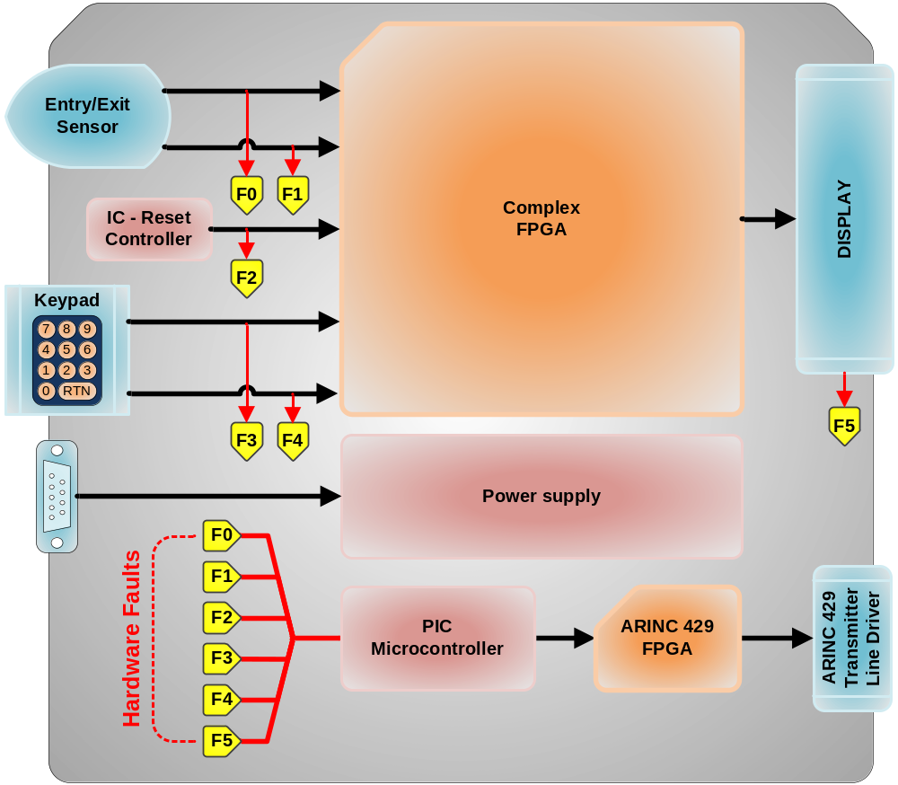

The passenger headcount function is performed by counting the number of entries and exits. The module uses an Entry/Exit-Sensor to detect passengers’ movements in and out of the cabin. The number of passengers in the cabin is tracked by an up/down counter in an FPGA. The passenger load is displayed in real-time on the display panel. The keypad entry can asynchronously load the counter thereby adjusting/correcting the passenger load on the display/system.

2.3 System Requirements

SYS 001 | Type: | Regulatory
Derived requirements shall be identified and verified.
Req Source: | DO-254
Safety Related: | False

SYS 002 | Type: | Customer
The System SHALL Provide entry and exit detection.
Req Source: | PTS-1234.1
Safety Related: | True

SYS 003 | Type: | Customer
The System SHALL provide keypad entry capability.
Req Source: | PTS-1234.2
Safety Related: | False

SYS 004 | Type: | Customer
The System SHALL provide a display.
Req Source: | PTS-1234.3
Safety Related: | False

SYS 005 | Type: | Customer
The System SHALL provide fault monitoring and 429 data transmit capability.
Req Source: | PTS-1234.4
Safety Related: | False

3.0 HARDWARE OVERVIEW
This section describes the hardware functions, hardware items, architecture, new technologies to be used, and any fail-safe, fault tolerant redundancy and partitioning techniques to be used.

3.1 Hardware Functions

There are five main hardware functions:

- Computation (Derived)
- Entry/Exit Detection
- Keypad entry
- Display
- Fault monitoring and ARINC 429 data transmit

3.2 Hardware Architecture

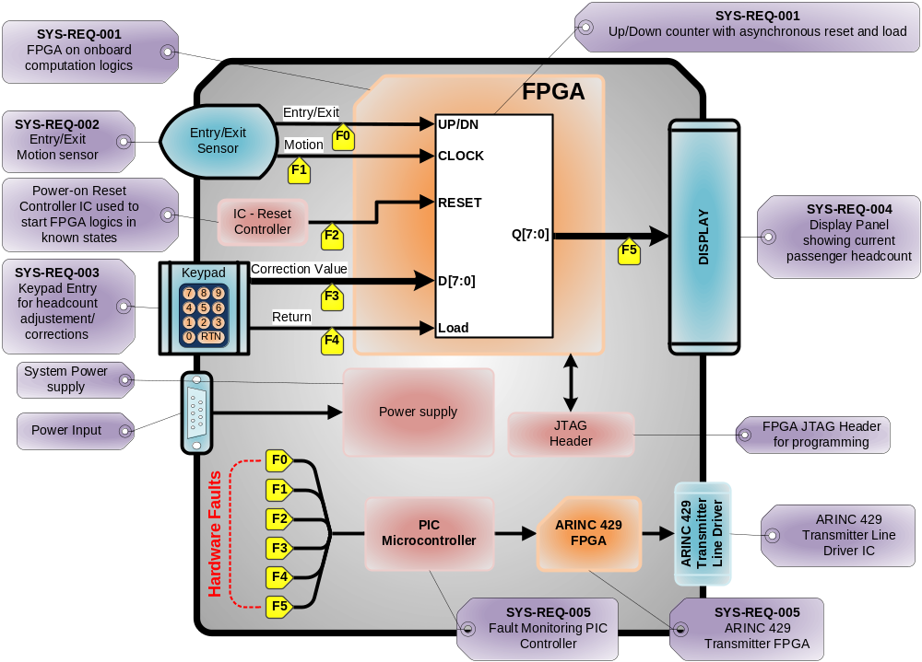

3.2.1 Computation

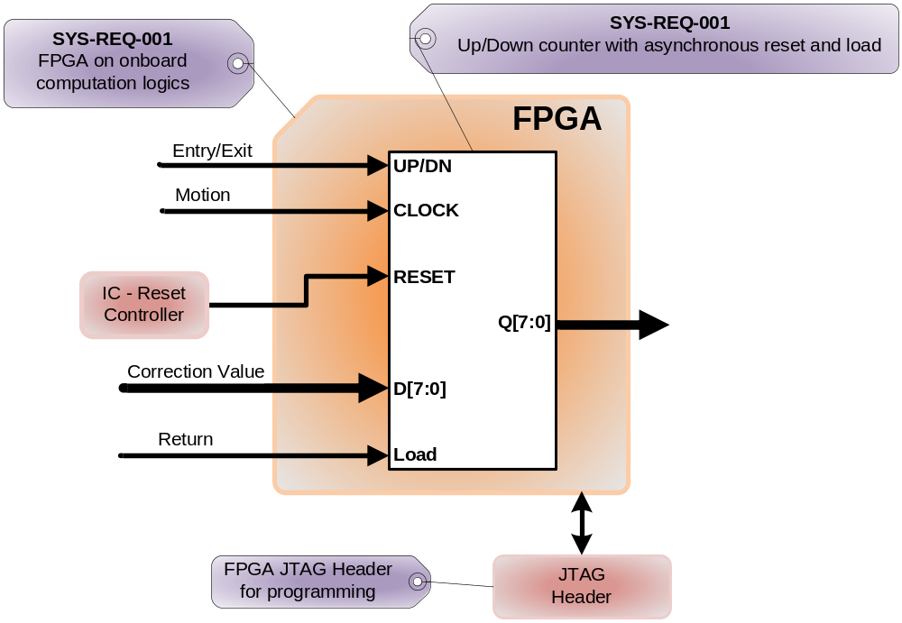

The headcount function is done by an up/down counter inside the FPGA. Every time the Entry/Exit motion sensor detects an entry or an exit, the counter increments or decrements accordingly. Every time the user presses return, the current headcount output is loaded with previously typed value. The truth table is shown below.

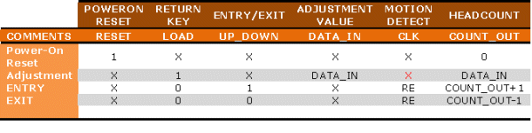

3.2.2 Entry/Exit sensor

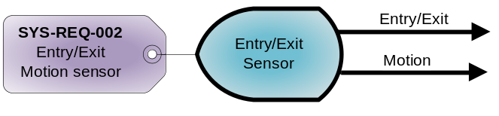
The Entry/Exit Detection function is performed by the Entry/Exit sensor. This sensor will detect human motion and decipher whether the motion is inward or outward. The information is then sent to the FPGA for headcount computation.

3.2.3 Keypad Entry Panel

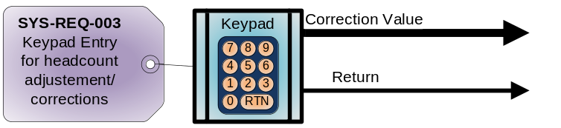

The headcount adjustment/correction data is generated by the keypad entry panel. This panel puts out a value typed by the user as well as a return key strobe signal. Both signals are sent to the FPGA for headcount adjustment/correction. The return key strobe signal is used to latch the value typed by the user into the FPGA logics.

3.2.4 Display Panel

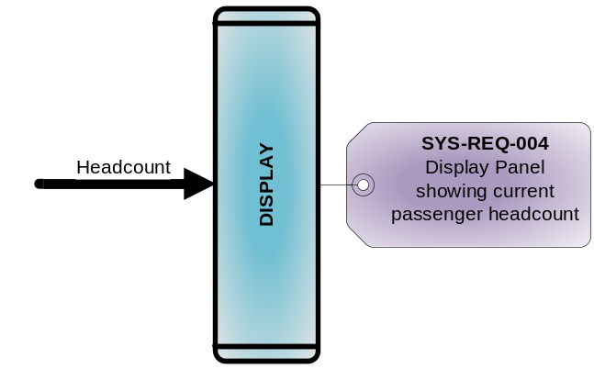
The display panel simply displays the current headcount outputted by the FPGA.

3.2.5 PIC Controller Interface & Fault Monitoring

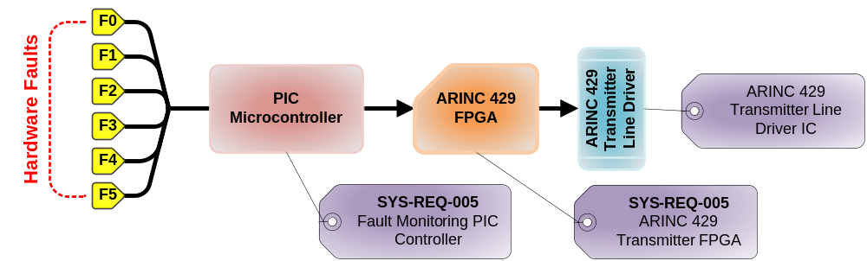

The Fault monitoring circuit monitors the sequences, timings and states of the Entry / Exit Detection sensor, Reset controller, keypad entry and the display panel. All of this information is fed to and analyzed by the PIC microcontroller. The PIC microcontroller’s software knows all the correct signal sequences, timing & states for all the interfaces. A fault is detected when a signal set is not within the predetermined constraints. The PIC controller then generates a fault message in the form able to fit into two 429 words which are sent to the FPGA. The FPGA then generates the appropriate serial ARINC 429 streams to the line driver which translates it out into the appropriate ARINC 429 signal level. The fault message is then sent to the maintenance computer via the ARINC 429 link. The cockpit multifunction display is used in maintenance aspects of the system. This is not a critical function and is used for maintenance and information only in the cockpit. The display reader provides the current passenger headcount to the flight attendant as the critical record for total headcount.

3.2.5.1 PIC Controller & ARINC 429 FPGA Interface

The ARINC 429 FPGA is connected to the PIC Microcontroller via a standard 8-bit bus interface. There are 8-bit data, 8-bit address and a chip-select (CE) line. There is also one GPIO that is used as an input to the PIC Microcontroller to indicate when the ARINC 429 FPGA is busy / sending data.

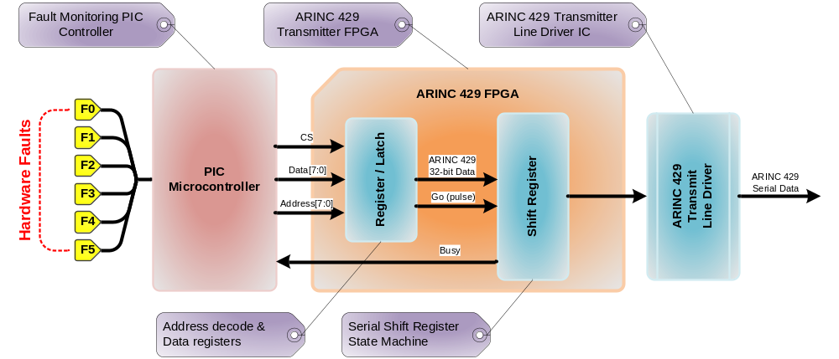

The ARINC 429 FPGA has to internal blocks: the Latch and the Shift Register. The Latch contains four 8-bit register that the Microcontroller can write to: each representing ¼ of the full ARINC 429 packet. These four register are made available to the next block in the form of a complete 32-bit bus/register to be loaded to the shift register. The Latch also contains a dummy register which, when written to, will send short pulse to the Shift Register. This short pulse will trigger the next block, the Shift register to load the data and serially shift out the data in the appropriate ARINC 429 format.

The final block in the ARINC 429 FPGA is the Shift Register. This block is really combination of a state machine and a shift register (shown in the figure below). The sole purpose of this block is to serially shift the 32-bit ARINC 429 data with the appropriate timings.

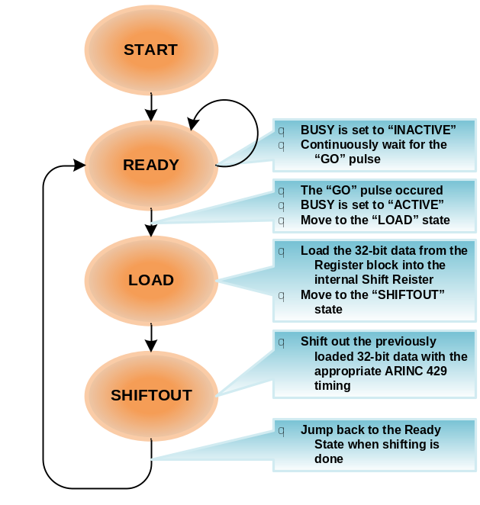

When a fault is detected, the PIC controller determines that a message needs to be sent. It internally constructs the 32-bit ARINC 429 packet in four bytes and writes them out into the FPGA Registers. The Microcontroller then waits for the Busy signal (from the FPGA Shift Register block) to indicate a ready state (inactive). When the Busy signal indicates a “ready” state, the controller writes to a dummy register to initiate the serial transfer.

3.3 Hardware Safety and Partitioning

The system is composed of diagnostics and other fail-safe mechanisms used to ensure that failures of the system are detected and that the system goes to a safe state if it's unable to perform a safety function. The hardware will be designed so that it will continue to operate, possibly at a reduced level, rather than failing completely, when some part of the system fails. During this condition, a visible fault indication will be present.

4.0 HARDWARE REQUIREMENTS IDENTIFICATION

4.1 System Level Requirements Allocated to Hardware

Section 3.2 of this document contains all system level requirements allocated to hardware. Each system level requirement is identified by a unique number and will be used to derive high level hardware requirements. Tables listed in this section are generated from outputs of the Requirements Traceability Management System.

4.2 High-Level Hardware Requirements Definition

This section also lists the high-level hardware requirements. Each requirement is identified by a unique number associated with primary sections.

4.3 Regulatory Compliance

001.0001 | Derived requirements shall be identified and verified

4.4 Computation

001.0002 | For each entry, the system shall increment the passenger headcount accordingly.

001.0003 | For each exit, the system shall decrement the passenger headcount accordingly.

4.5 Entry / Exit Detection

002.0004 | The system shall have a sensor to detect passenger entry and exit motions.

002.0005 | The system's Entry/Exit motion sensor shall be capable of distinguishing entry from exit.

4.6 Keypad Entry

003.0006 | The system shall have a numerical keypad entry.

003.0007 | The numerical keypad entry shall have an "enter"/"return" button.

003.0008 | The system shall update the passenger headcount by the keypad's value when the user presses the "return" button.

4.7 Display

004.0009 | The system shall have a numerical display.

004.0010 | The systems numerical display shall display the current passenger headcount.

4.8 Fault Monitoring and ARINC 429 Data Transmit

005.0011 | The fault monitoring system shall monitor signal waveforms between the FPGA and the peripheral components to determine if established thresholds have been violated.

005.0012 | When a fault condition is detected by the fault monitoring circuit, an ARINC 429 label word shall be created by the Microcontroller.

005.0013 | The microcontroller shall write the ARINC 429 word into the ARINC 429 FPGA.

005.0014 | The ARINC 429 FPGA, when signaled by the microcontroller, shall serially shift out the previously loaded data.

005.0015 | The serial data rate shall be 100k bits per second.

005.0016 | The serial data rate shall not vary by more than 1%.

005.0017 | The serial data shall be converted to a differential (line A & B) tri-level RZ state modulation output consisting of “HI,” “NULL” and “LO” states.

005.0018 | The serial data’s differential output signal across the specified output terminals (balanced to ground at the transmitter) shall be +10V with +/-1.0V from line A to line B for a "HI" state when the transmitter is open circuit.

005.0019 | The serial data’s differential output signal across the specified output terminals (balanced to ground at the transmitter) shall be +0V with +/-0.5V from line A to line B for a "NULL" state when the transmitter is open circuit.

005.0020 | The serial data’s differential output signal across the specified output terminals (balanced to ground at the transmitter) shall be -10V with +/-1.0V from line A to line B for a "LO" state when the transmitter is open circuit.

005.0021 | The serial data’s differential output signal across the specified output terminals (balanced to ground at the transmitter) shall be +5V with +/-0.5V from line A to ground for a "HI" state when the transmitter is open circuit.

005.0022 | The serial data’s differential output signal across the specified output terminals (balanced to ground at the transmitter) shall be +0V with +/-0.25V from line A to ground for a "NULL" state when the transmitter is open circuit.

005.0023 | The serial data’s differential output signal across the specified output terminals (balanced to ground at the transmitter) shall be -5V with +/-0.5V from line A to ground for a "LO" state when the transmitter is open circuit.

005.0024 | The serial data’s differential output signal across the specified output terminals (balanced to ground at the transmitter) shall be +5V with +/-0.5V from line B to ground for a "HI"state when the transmitter is open circuit.

005.0025 | The serial data’s differential output signal across the specified output terminals (balanced to ground at the transmitter) shall be +5V with +/-0.5V from line B to ground for a "HI"state when the transmitter is open circuit.

005.0026 | The serial data’s output signal across the specified output terminals (balanced to ground at the transmitter) shall be +0V with +/-0.25V from line B to ground for a "NULL"state when the transmitter is open circuit.

005.0027 | The serial data’s differential output signal across the specified output terminals (balanced to ground at the transmitter) should be -5V with +/-0.5V from line B to ground for a "LO"state when the transmitter is open circuit.

005.0028 | The serial data’s “HI” state shall be at the beginning of the bit interval returning to a “NULL” state before the end of the same bit interval signifies a logic “one.”.

005.0029 | The serial data’s “LO” state after shall be at the beginning of the bit interval returning to a “NULL” state before the end of the same bit interval signifies a logic “zero.”.

005.0030 | The serial data’s output word shall be synchronized by reference to a gap of four bit times (minimum) between the periods of word transmissions. The beginning of the first transmitted bit following this gap signifies the beginning of the new word.

005.0031 | The serial data output transmitter's Rise and Fall Time shall be 1.5 micro seconds with a +/-0.5 micro second tolerance.

5.0 Passenger Counter FPGA Requirements Diagram

The system shall implement an 8-bit up/down counter with parallel load and asynchronous reset. When enable is true the counter will load if load is true otherwise it will count up or down depending on state of up down as depicted in the following figure and table.

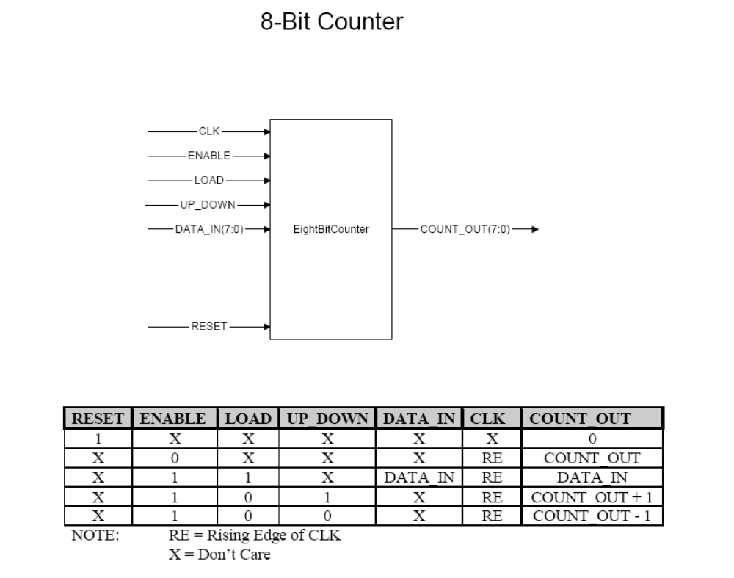

6.0 REQUIREMENTS TRACEABILITY MATRIX

  - Hardware Requirements To Code

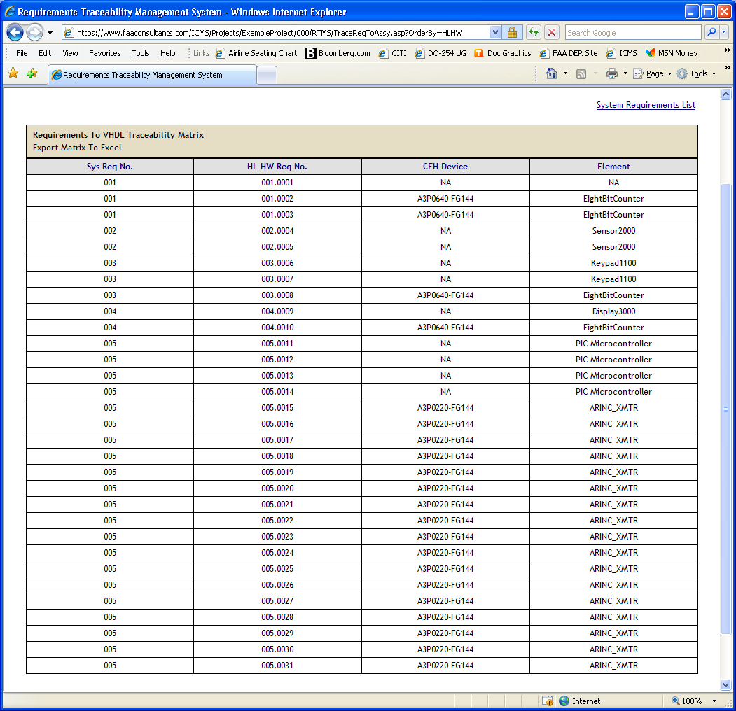
6.2 Hardware Requirements To Test

